**Advance MongoDb**

1. **Add 50 User and 100 Address Collection, One User has multiple Address.**

**User properties - name, age, companyName, type, fatherName, motherName, Address ArrayIds as references.**

**Address Properties - houseNo, landmark, city, state, pincode.**

**Write a query for to fetch all address data from address in users. Limit should be 10 and skiping first five.**

Solution :

db.user.find().pretty() to show data i already have in my user collection  
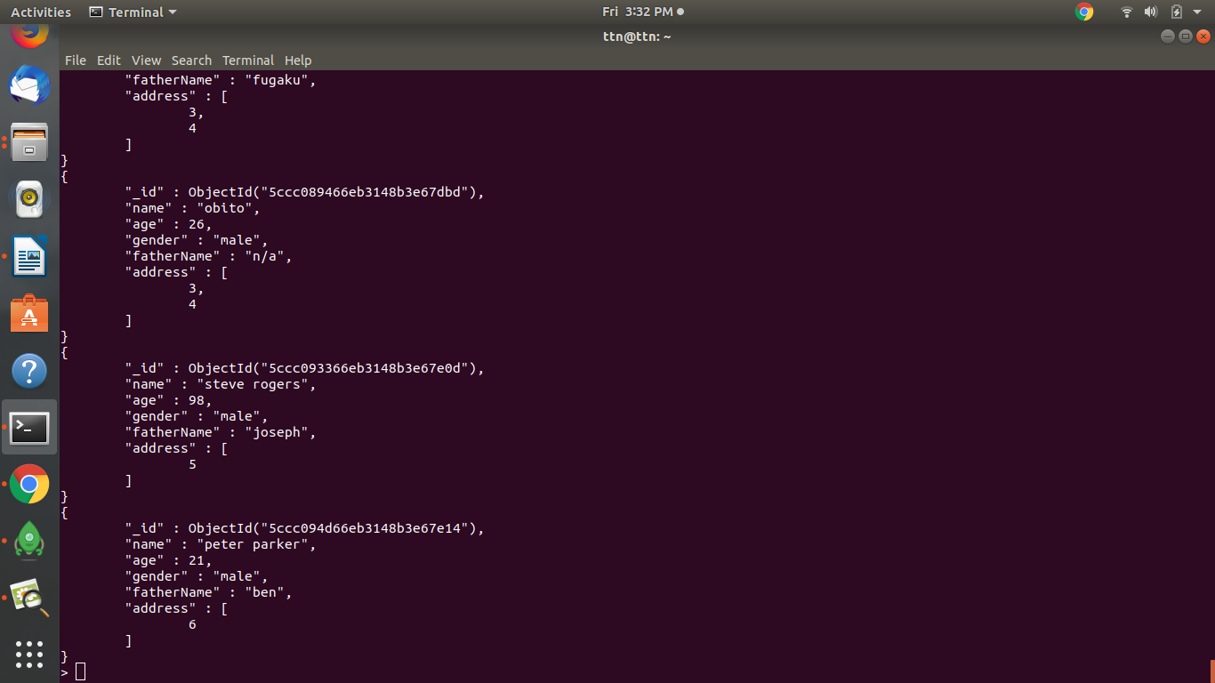

db.user.aggregate([{$lookup:{from :'address',localField:'address', foreignField:'id', as:'address-details'}},{$skip:1},{$limit:3}]).pretty();  
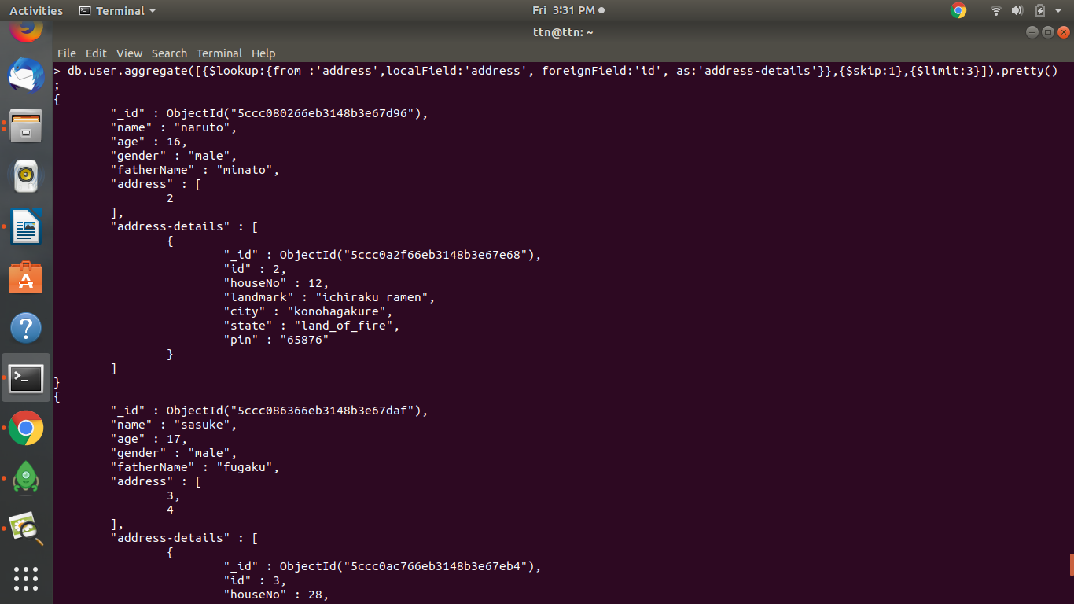

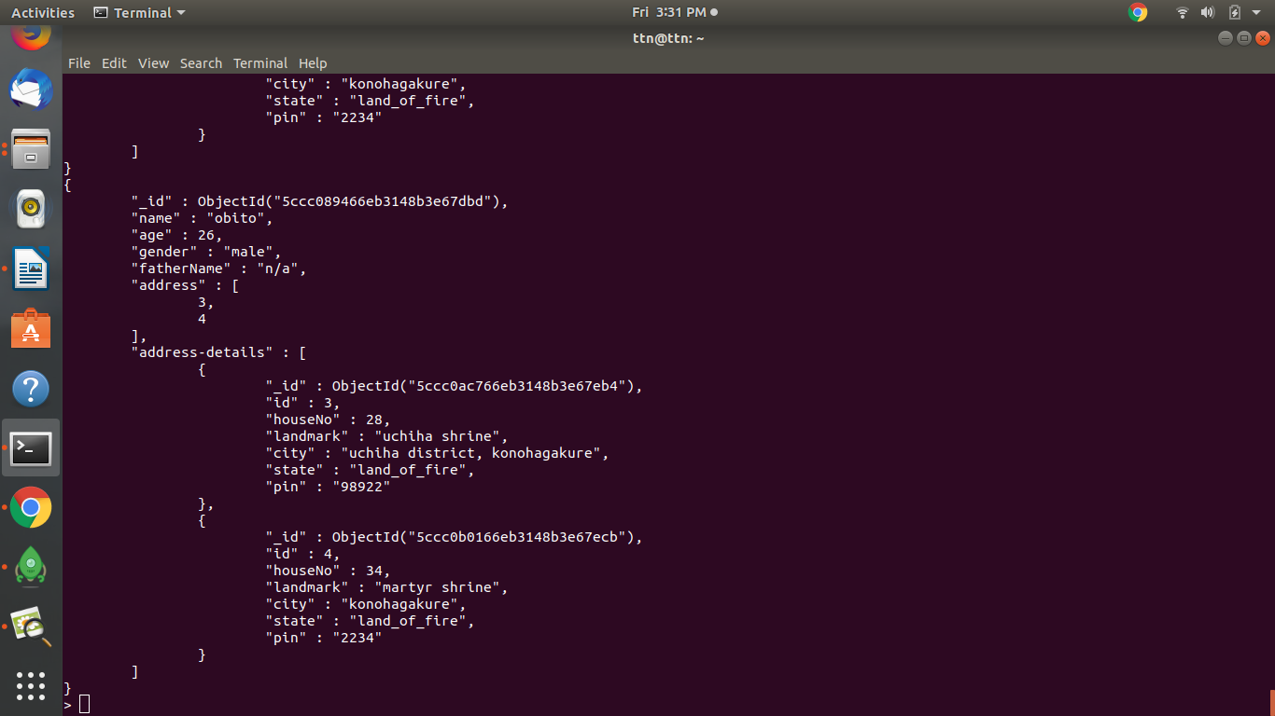

**2. Fetch & Sort User data on base of user names, Sort Address cities in User table. Limit should be 5 and skipping first 5.**  
Solution :   
Query made to sort only on ‘name’ only because performing it on address shows same results as simple find().  
  
db.user.find().sort({name:1}).skip(1).limit(4).pretty();

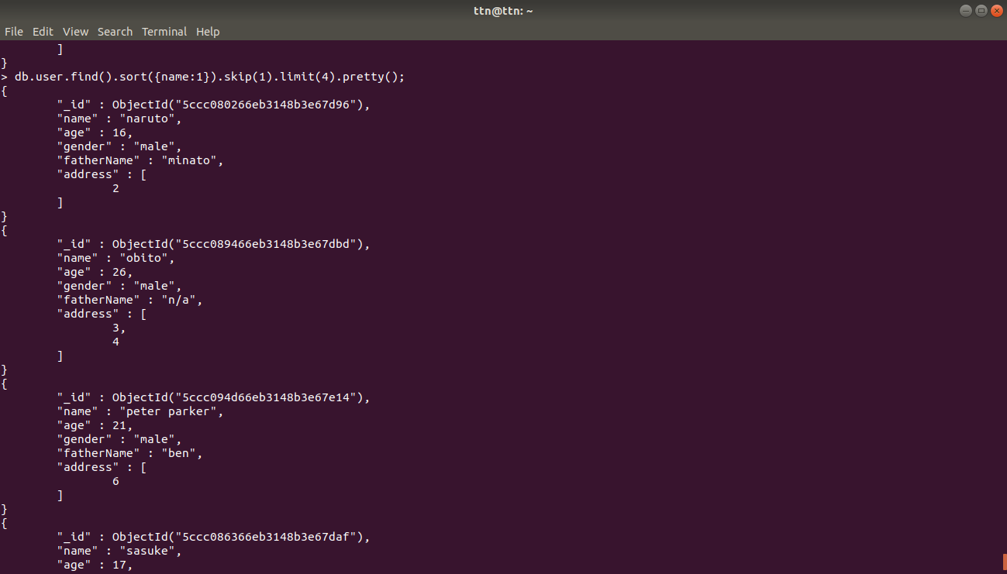

**3. Fetch only address selective data (UserID:””, AddressData:”” ) from user table, keys should be like above.**

Solution :

db.user.aggregate([{$lookup:{from :'address',localField:'address', foreignField:'id', as:'AddressData'}},{$unwind:"$AddressData"},{$project:{_id:1,AddressData:1}}]).pretty();  
  
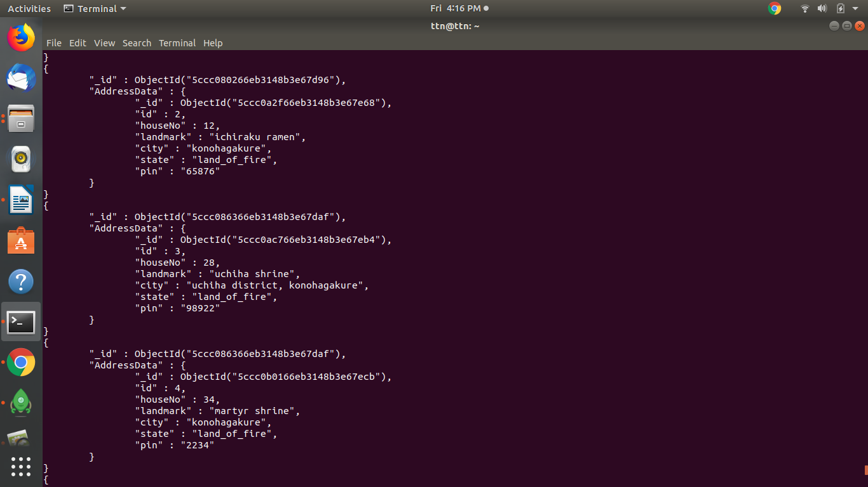

**4. Create indexes in Address table, on city and state. And Sort it.**

Solution :

